Founding Fathers’ Web Quest

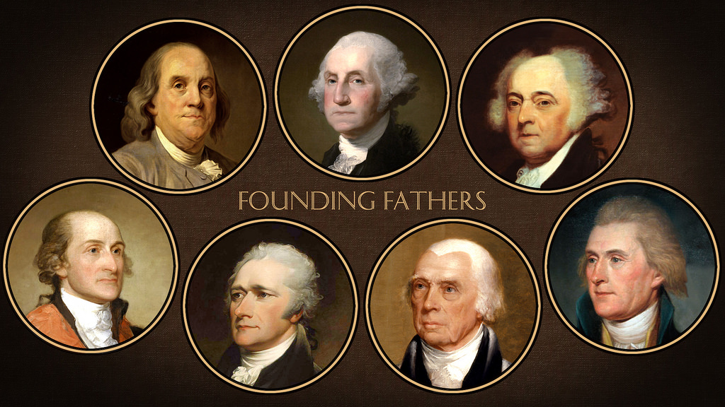

George Washington

Below are three questions about George Washington. To answer these questions you will need to click on the links below the questions.

