Name:______________________________________________________________________ Period:_____
Columbian Exchange Worksheet
The Columbian Exchange was the global diffusion of plants, food crops, animals, human populations, and disease pathogens that took place after the voyages of Christopher Columbus (1492) and other European mariners. It had both positive and negative consequences for the global world.

1. Look at the Columbian Exchange map below. Use the map to fill in the chart below.
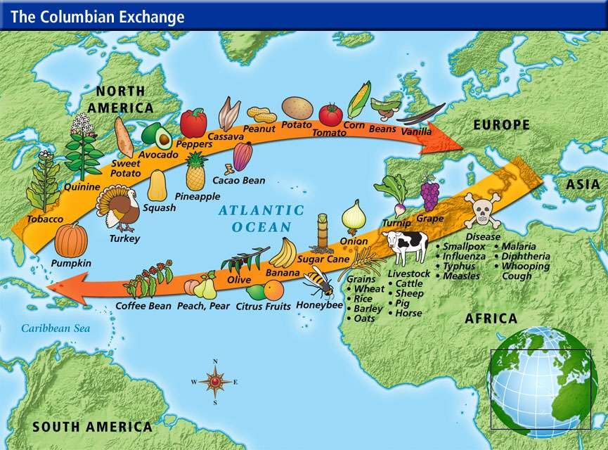
 | New World (The Americas) | Old World (Europe)
Domesticated Animals
Domesticated Plants
2. Select the three most used food commodities (plants that are used for food) and list all of their modern-day uses.

3. What effects did new foods have on people as a result of the exchange?

4. Use your notes or your textbook to complete the following chart
Positive Effects of the Columbian Exchange | Negative Effects of the Columbian Exchange

5. Write a paragraph discussing the positive and negative effects that the Columbian Exchange had on the people in the Americas and the people in Europe.
____________________________________________________________________________________________________________________________________________________________________________________________________________________________________________________________________________________________________________________________________________________________________________________________________________________________________________________________________________________________________________________________________________________________________________________________________________________________________________________________________________________________________________________________________________________________________________________________________________________________________________________________________________________________________________________________________________________________________________________________________________________

